**A room at morning, with a dining table and 2 chairs.**

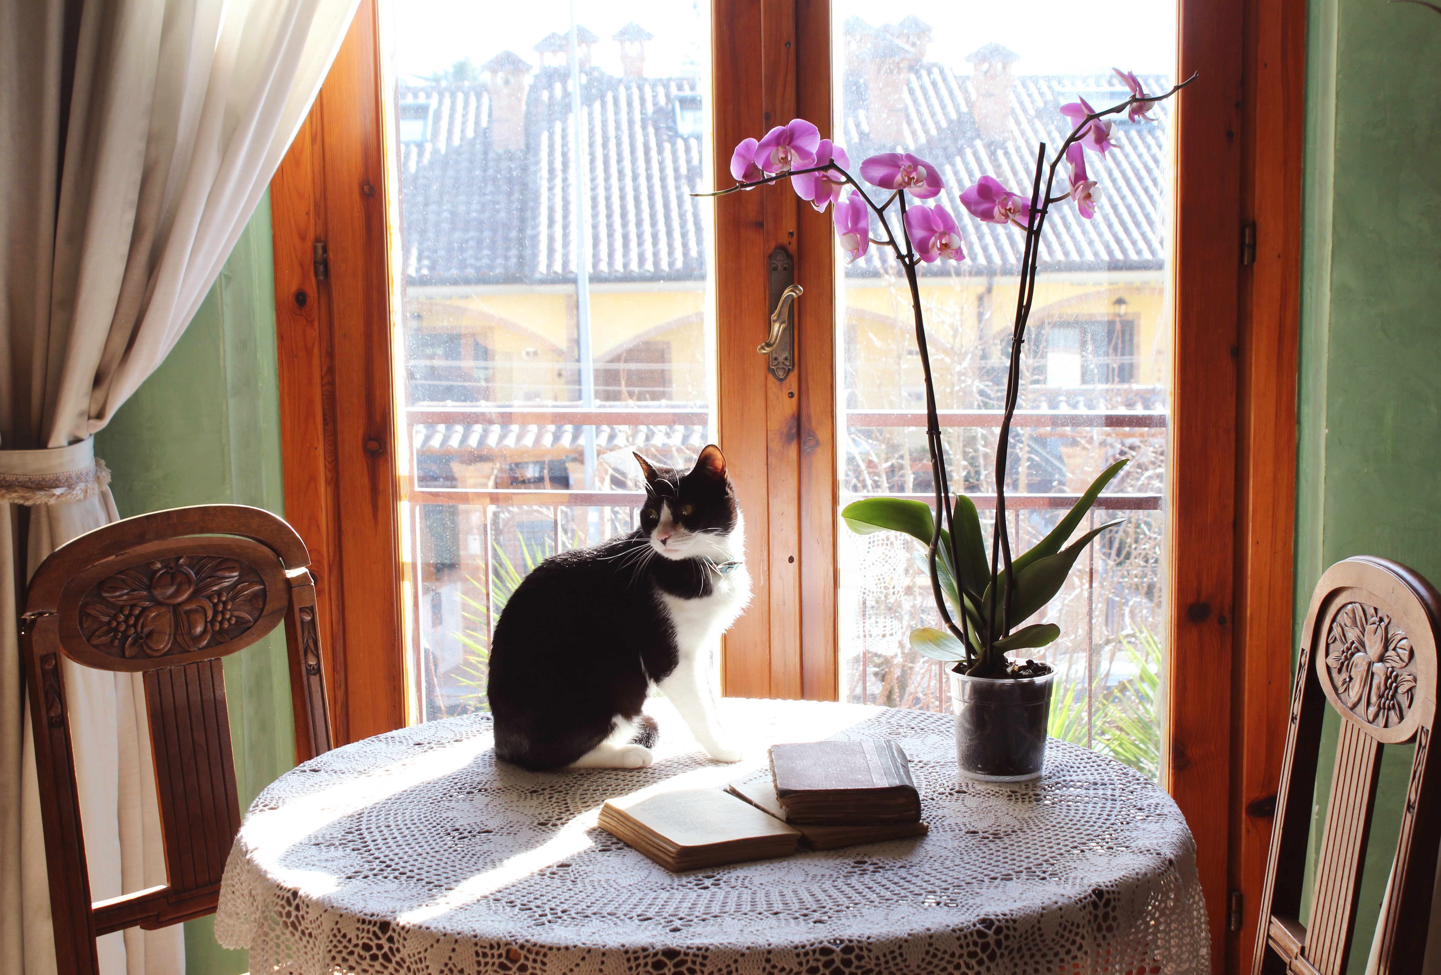

Building behind a transparent window

cat sits on a table and looks back